**Practical no.09**

**Aim:** – Demo of Time Series Forecasting

Theory:

Time series forecasting is a method in the statistics field to analyze historical data with a time component and create a prediction based on it.Some classic examples of time series forecasting methods are Moving Average, ARIMA, and Exponential Smoothing. These methods have been used for a long time and are still useful now because of how easy it is for users to explain the result — although with less accurate prediction.Whether you need a classical approach or a machine learning-driven model, many have developed Python packages to access all these methods. Some of the famous packages are Statsmodel, pmdarima, and sktime.However, the forecasting model is not limited to only the ones that are listed above because many great packages are worthy of consideration.

1. StatsForecast – It is a Python package that provides a collection of univariate time-series Forecasting models. What is unique about StatsForecast is the model provides fast training and is optimized for high-accuracy models. Also, the package offers several benchmarks we could use when training various models.

2. PyAF - PyAF or Python Automatic Forecasting is an open-source Python package to automatically

develop time-series forecasting models (either univariate or with exogenous data). The model was

built on top of Scikit-Learn and Pandas, so expect familiar APIs. The package also offers various

models to use in a few lines as much as possible.

3. NeuralProphet - It is a Python Package for developing a time-series model based on Facebook Prophet but with Neural Network architecture. The package is based on PyTorch and could easily be used with as few lines as possible.

Install packages using timeSeries and forecast

> install.packages(“forecast”)

> install.packages(“timeSeries”)

**And use both the libraries**

> library(forecast)

> library(timeSeries)

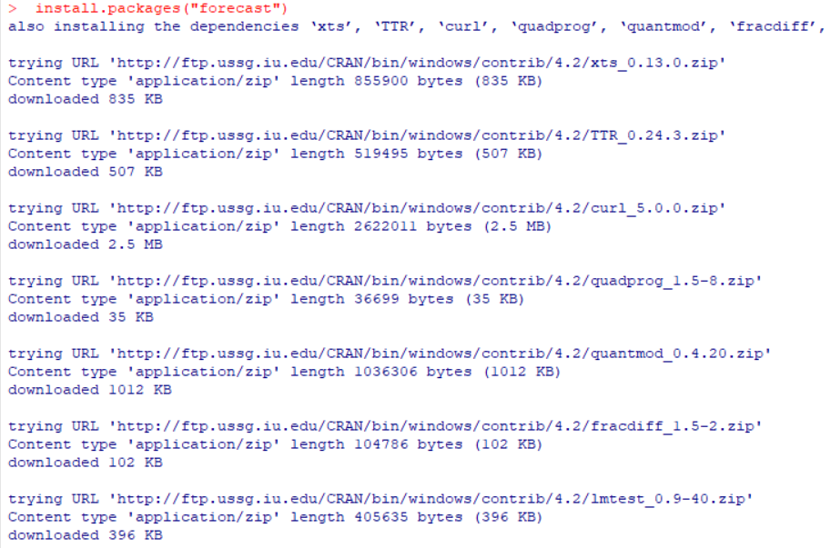

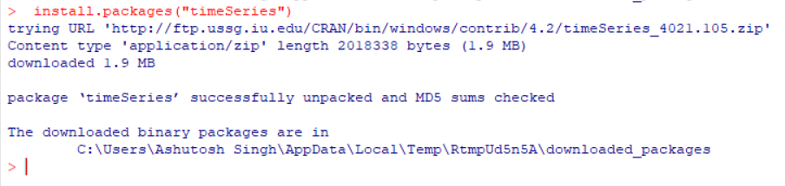

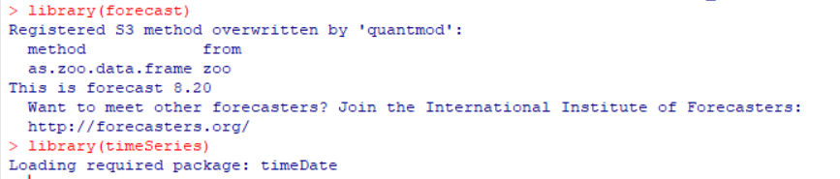 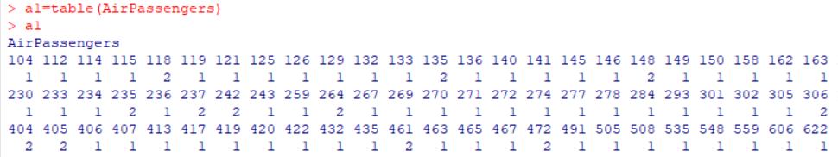

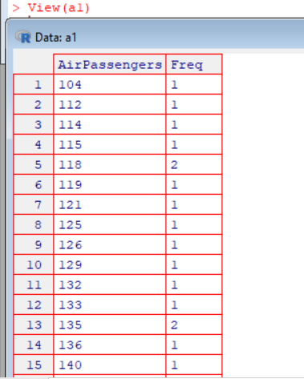

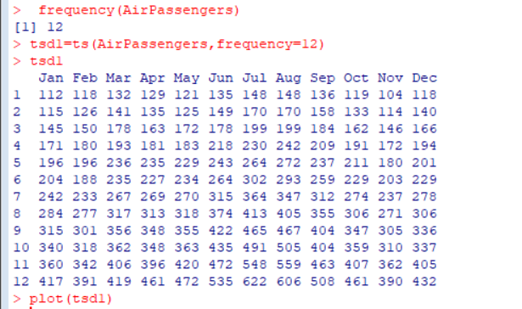

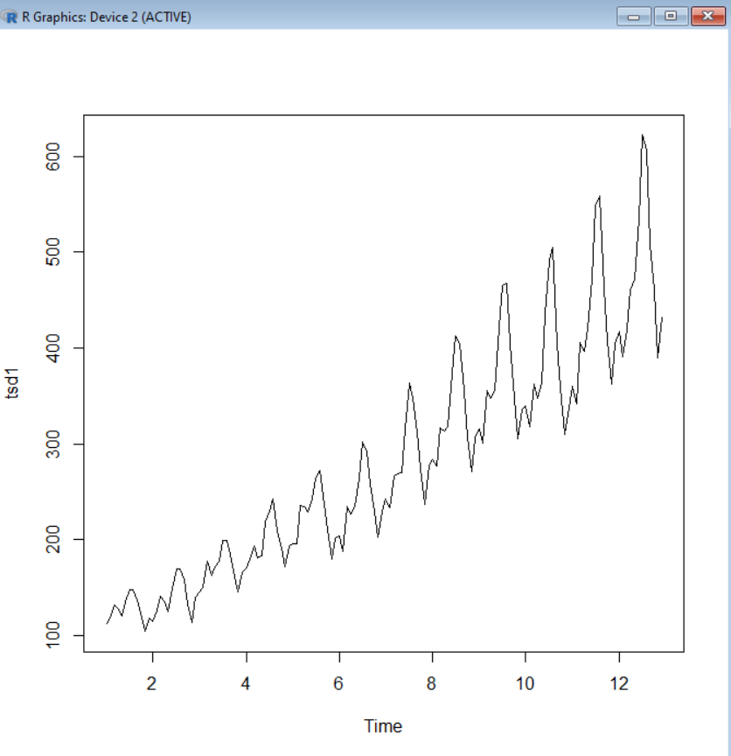

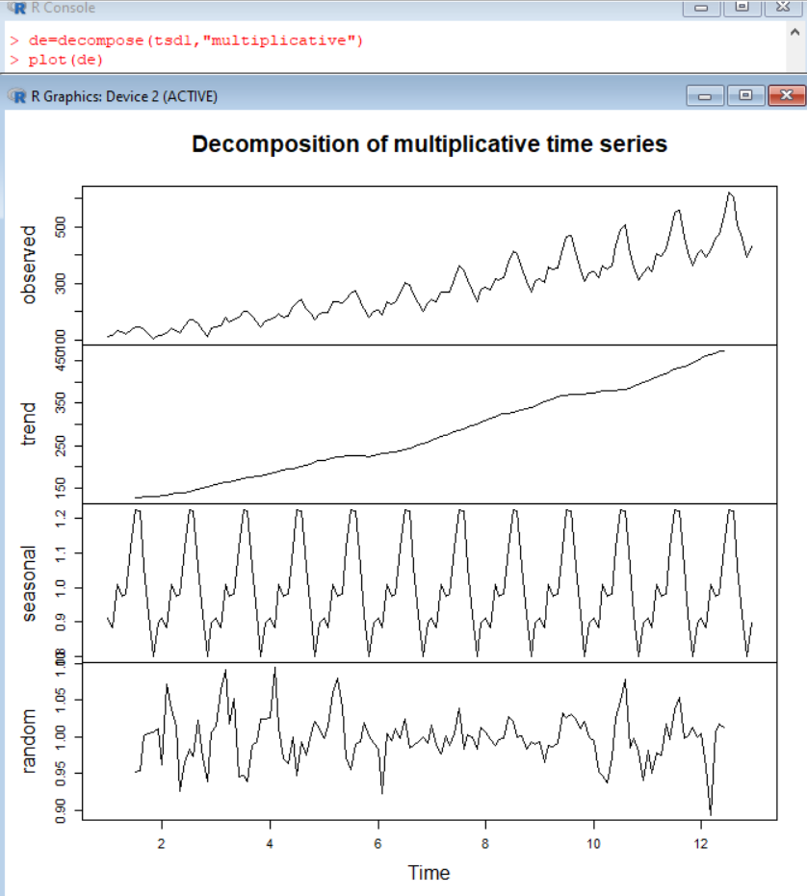 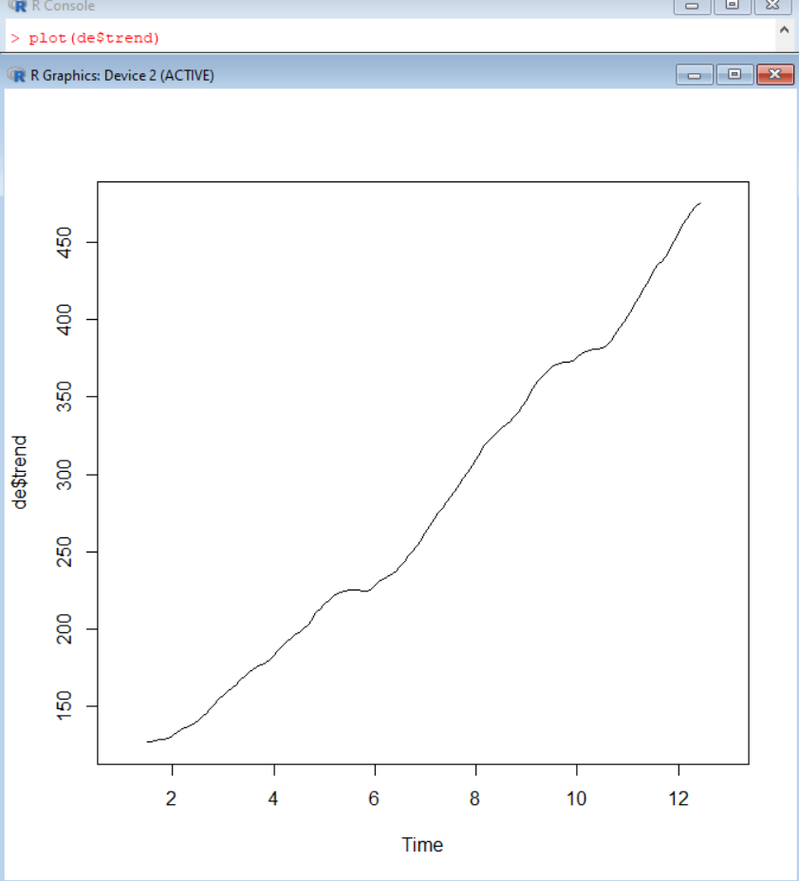

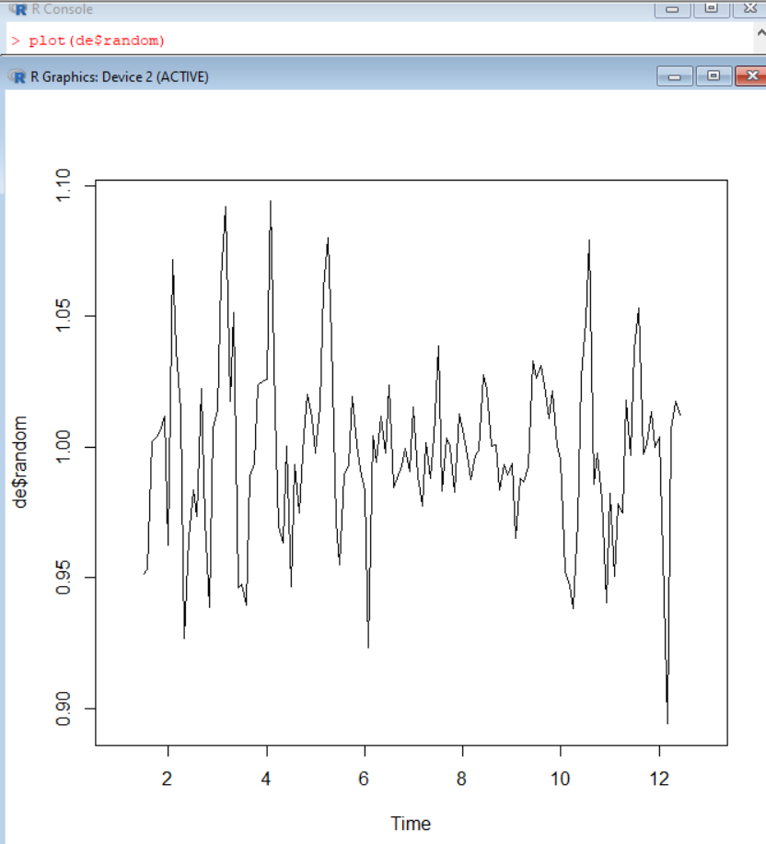 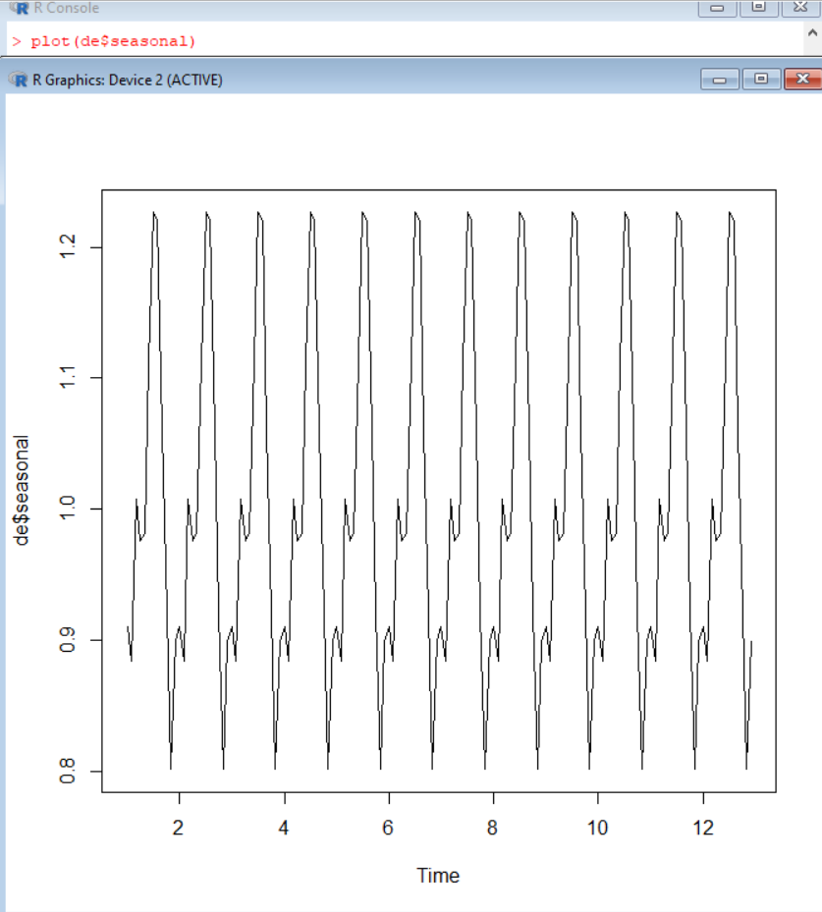

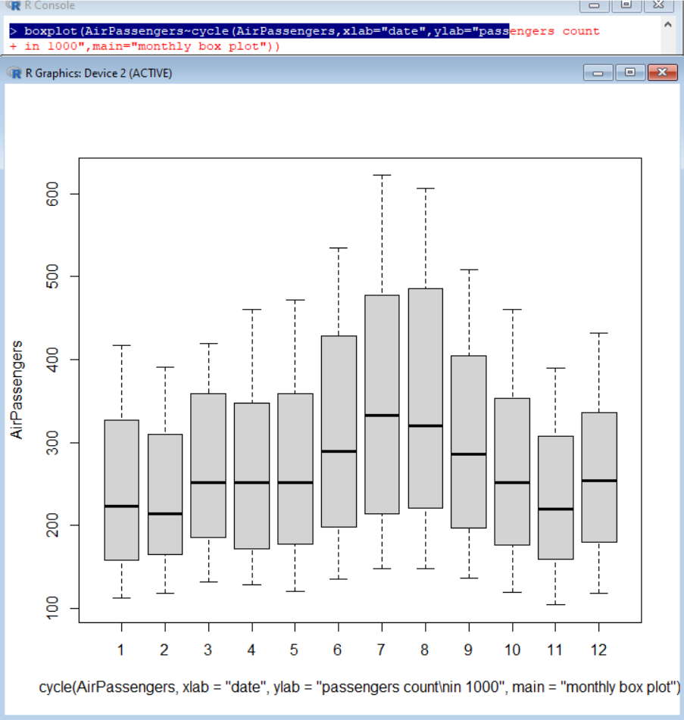 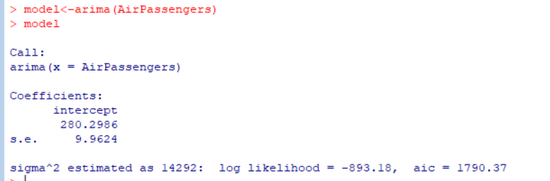

**Conclusion:** Thus we have implemented Time Series Forecast successfully.